**FE5222 ADP Project Two**

Ho Ngok Chao, Gao Jichen, Cheng Tuoyuan

# Introduction

Spread options have terminal payoffs based on the difference in prices between two underlying assets together with a strike. When the strike equals $0$, the spread option is equivalent to an option to exchange one asset for another, where the Margrabe’s formula works as an explicit solution **[1], [2]**. The Kirk’s approximation as published in 1995, is a valid formula when the strike is small but non-zero, where a special sigma is adopted into the generalized Black-Scholes option pricing **[3]–[5]**.

In this project, we would investigate the spread option pricing via Kirk’s approximation, and employ the Monte Carlo (MC) simulation output as a benchmark. Results from both methods are compared and discussed in various scenarios.

# Materials and Methods

## Monte Carlo Simulation

The process of using Monte Carlo simulation to price spread call option is similar to the process of pricing European vanilla option. The initial step is to generate terminal prices for the two correlated stocks’ geometric Brownian motions:

$$S_{1}\left(T\right)=S_{1}\left(0\right)e^{\left(r-0.5σ_{1}^{2}\right)T+σ_{1}W_{1}(T)} \\ S_{2}\left(T\right)=S_{2}\left(0\right)e^{\left(r-0.5σ_{2}^{2}\right)T+σ_{2}\left({ρW}_{1}(T)+\sqrt{1-ρ^{2}}W_{2}(T)\right)}$$

The simulation is repeated multiple times. Then we calculate the payoff for each simulation at expiry:

$$payoff=max⁡\{S_{1}\left(T\right)-S_{2}\left(T\right)-K, 0\}$$

By taking expectation and involving discount factors, we would arrive at the Monte Carlo estimated spread call value.

## Kirk’s Approximation

Kirk’s approximation represents a closed form approximation formula to price a European spread option:

$$C\left(S_{1},S_{2},T\right)=S_{1}N\left(d_{1}\right)-\left(S_{2}+Ke^{-rT}\right)N\left(d_{2}\right)$$

Where $S_{i}$ is the stock’s price, N is the distribution function of a standard normal distribution

$$d_{1,2}=\frac{\ln\left(S_{1}/\left(S_{2}+Ke^{-rT}\right)\right)±\frac{1}{2}σ^{2}T}{σ\sqrt{T}}$$

And

$$σ=\sqrt{σ_{1}^{2}+σ_{2}^{2}{\left(\frac{S_{2}}{S_{2}+Ke^{-rT}}\right)}^{2}-2ρσ_{1}σ_{2}\left(\frac{S_{2}}{S_{2}+Ke^{-rT}}\right)}$$

Proof: Let S1(t) and S2(t) be the prices of two stocks such that

$$\frac{dS_{i}\left(t\right)}{S_{i}\left(t\right)}=rdt+σ_{i}dW_{i}\left(t\right), i=1,2$$

And

$$dW_{1}\left(t\right)dW_{2}\left(t\right)=ρdt$$

By risk neutral pricing on Measure P, we have the value of the spread option

$$V(0)=E\left[e^{-rT}{\left(S_{1}\left(T\right)-S_{2}\left(T\right)-K\right)}^{+}\right]$$

Let $Y\left(t\right)=S_{2}\left(t\right)+Ke^{-r\left(T-t\right)}$. Hence,

$$V(0)=E\left[e^{-rT}{\left(S_{1}\left(T\right)-Y\left(T\right)\right)}^{+}\right]$$

By Ito’s formula,

$$dY\left(t\right)=ke^{-r\left(T-t\right)}rdt+dS_{2}\left(t\right)=rY\left(t\right)dt+S_{2}\left(t\right)σ_{2}dW_{2}(t)$$

Using the correlation assumptions and $W_{2}(t)$ is a standard Brownian motion

$$dY\left(t\right)=rY\left(t\right)dt+S_{2}\left(t\right)σ_{2}\left(ρdW_{1}\left(t\right)+\sqrt{1-ρ^{2}}dZ\left(t\right)\right)$$

Where Z(t) is a standard Brownian motion independent from $W_{1}\left(t\right)$

To make both $Y\left(t\right)$ and $S_{1}\left(t\right)$ both using the same Brownian motion, we rewrite them in vector form,

$$\frac{dS_{1}\left(t\right)}{S_{1}\left(t\right)}=rdt+Σ⋅d\tilde{W}\left(t\right)$$

And

$$\frac{dS_{1}\left(t\right)}{S_{1}\left(t\right)}=rdt+Σ'⋅d\tilde{W}\left(t\right)$$

Where $Σ=\left(σ_{1,}0\right)$ and $Σ^{'}=\left(ρ\frac{S_{2}(t)}{Y\left(t\right)}σ_{2},S_{2}(t)σ_{2}\sqrt{1-ρ^{2}}\right)$, by similar logic deriving the exchange option pricing formula provided lecture note we have

$$σ=\sqrt{σ_{1}^{2}+σ_{2}^{2}{\left(\frac{S_{2}}{S_{2}+Ke^{-rT}}\right)}^{2}-2ρσ_{1}σ_{2}\left(\frac{S_{2}}{S_{2}+Ke^{-rT}}\right)}$$

For K << S2, assume Y (t) also follows log-normal (which is an assumption of Black-Scholes formula which in turn used in our derivation for Exchange Option’s formula), and apply the formula for exchange option we derived in class

$$C\left(S_{1},S_{2},T\right)=V(0)=S_{1}N\left(d_{1}\right)-Y(0)N\left(d_{2}\right)$$

$$=S_{1}N\left(d_{1}\right)-\left(S_{2}+Ke^{-rT}\right)N\left(d_{2}\right)$$

And

$$d_{1,2}=\frac{\ln\left(S_{1}/\left(S_{2}+Ke^{-rT}\right)\right)±\frac{1}{2}σ^{2}T}{σ\sqrt{T}}$$

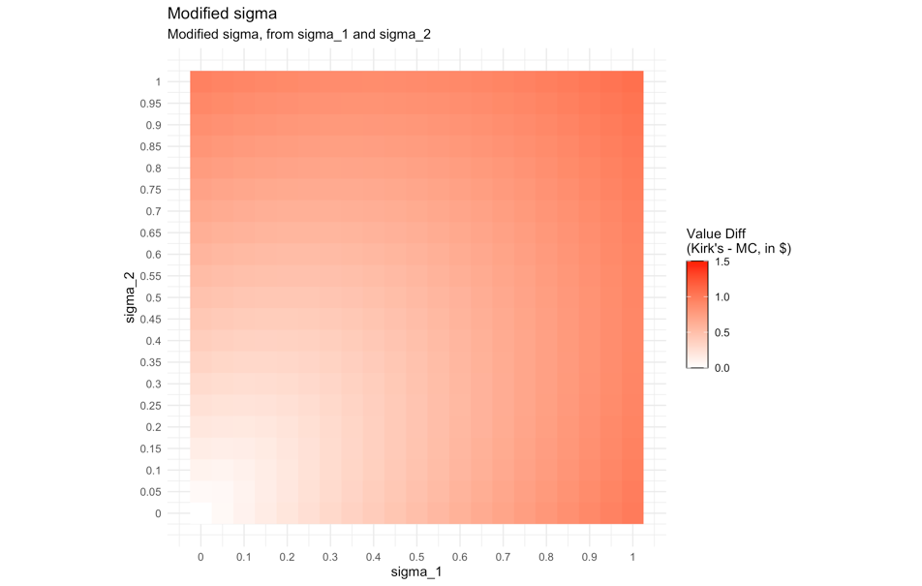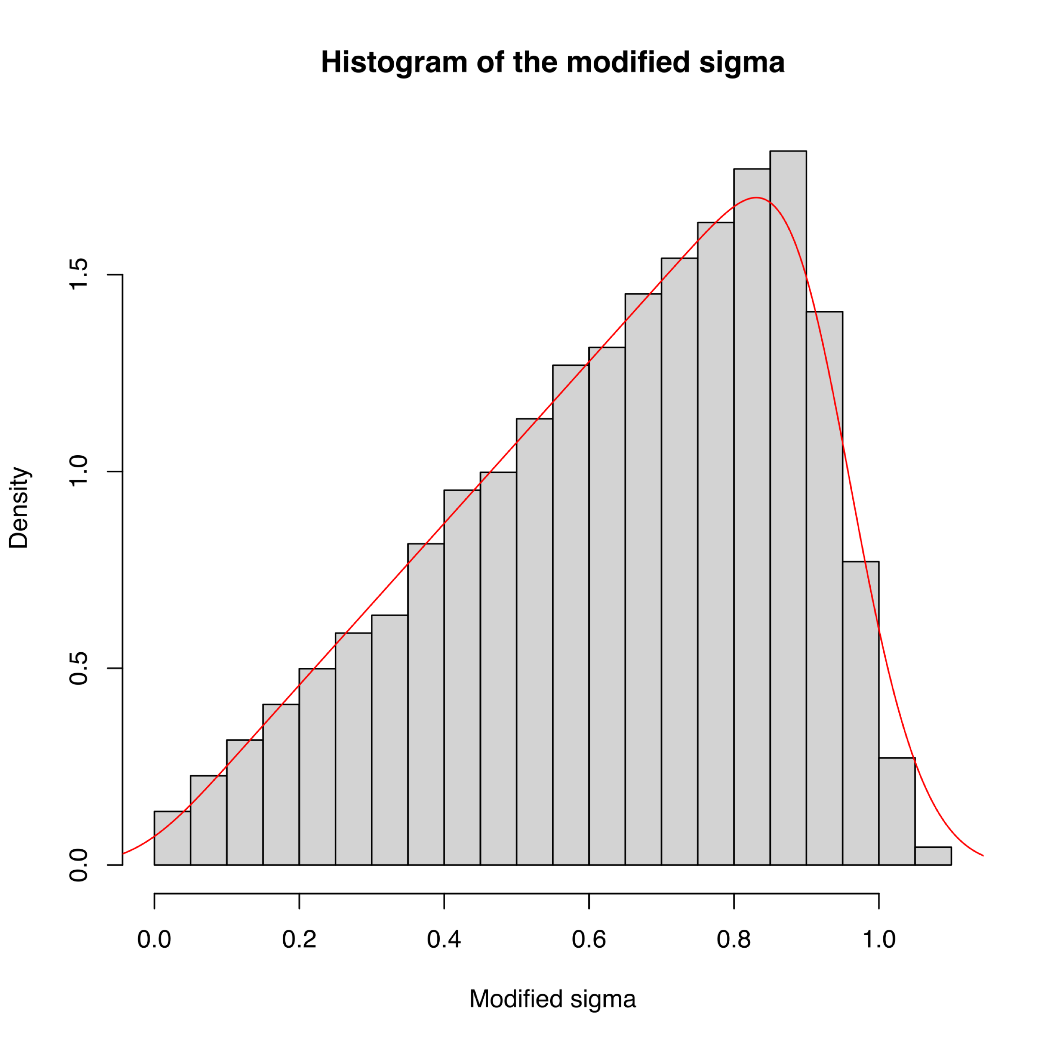

Figure 1. The modified $σ$, as calculated using $σ_{1}$ and $σ_{2}$, ranges from 0.00 to 1.07   
with a negative skewness of -0.51 and a negative excess kurtosis of -0.60.

## Comparison and Visualization

To compare the two investigated methods with respect to pricing parameters, we further performed pairwise pricing and visualized their differences (Kirk’s – MC’s) over two dimensional grids with red-white-blue color scales. To improve comparability, we kept the color scale bar centered around $0. Investigated pricing parameters with default values includes: Spot difference between the two stocks ($S_{0,1}-S_{0,2}, SpotDiff$) = $110 - $100 = $10, Strike as in percentage of $Spotdiff$ ($\frac{K}{SpotDiff}$) = $\frac{\$ 5}{\$ 10}$ = 50%, volatility of the first stock ($σ_{1}$) = 0.2, volatility of the second stock ($σ_{2}$) = 0.2, instantaneous correlation ($ρ$) = 0.4, interest rate ($r$) = 0.08, and time to maturity ($mT$) = 1. They are explored using equal spaced grids in corresponding plots but kept constant otherwise. To keep reproducibility and accelerate convergence, all Monte Carlo pricing schemes share the same initial random seed with 1,000,000 paths and antithetic variates. Visualizations are implemented in RStudio via packages ‘tidyverse’ and ‘ggplot2’ **[6], [7]**.

# Results and Discussion

## Grid comparison for pricing parameters

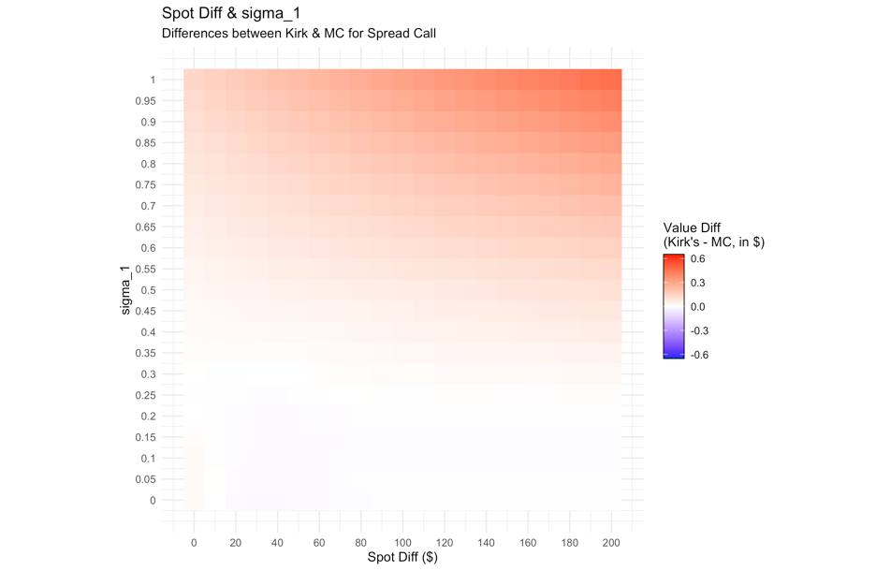 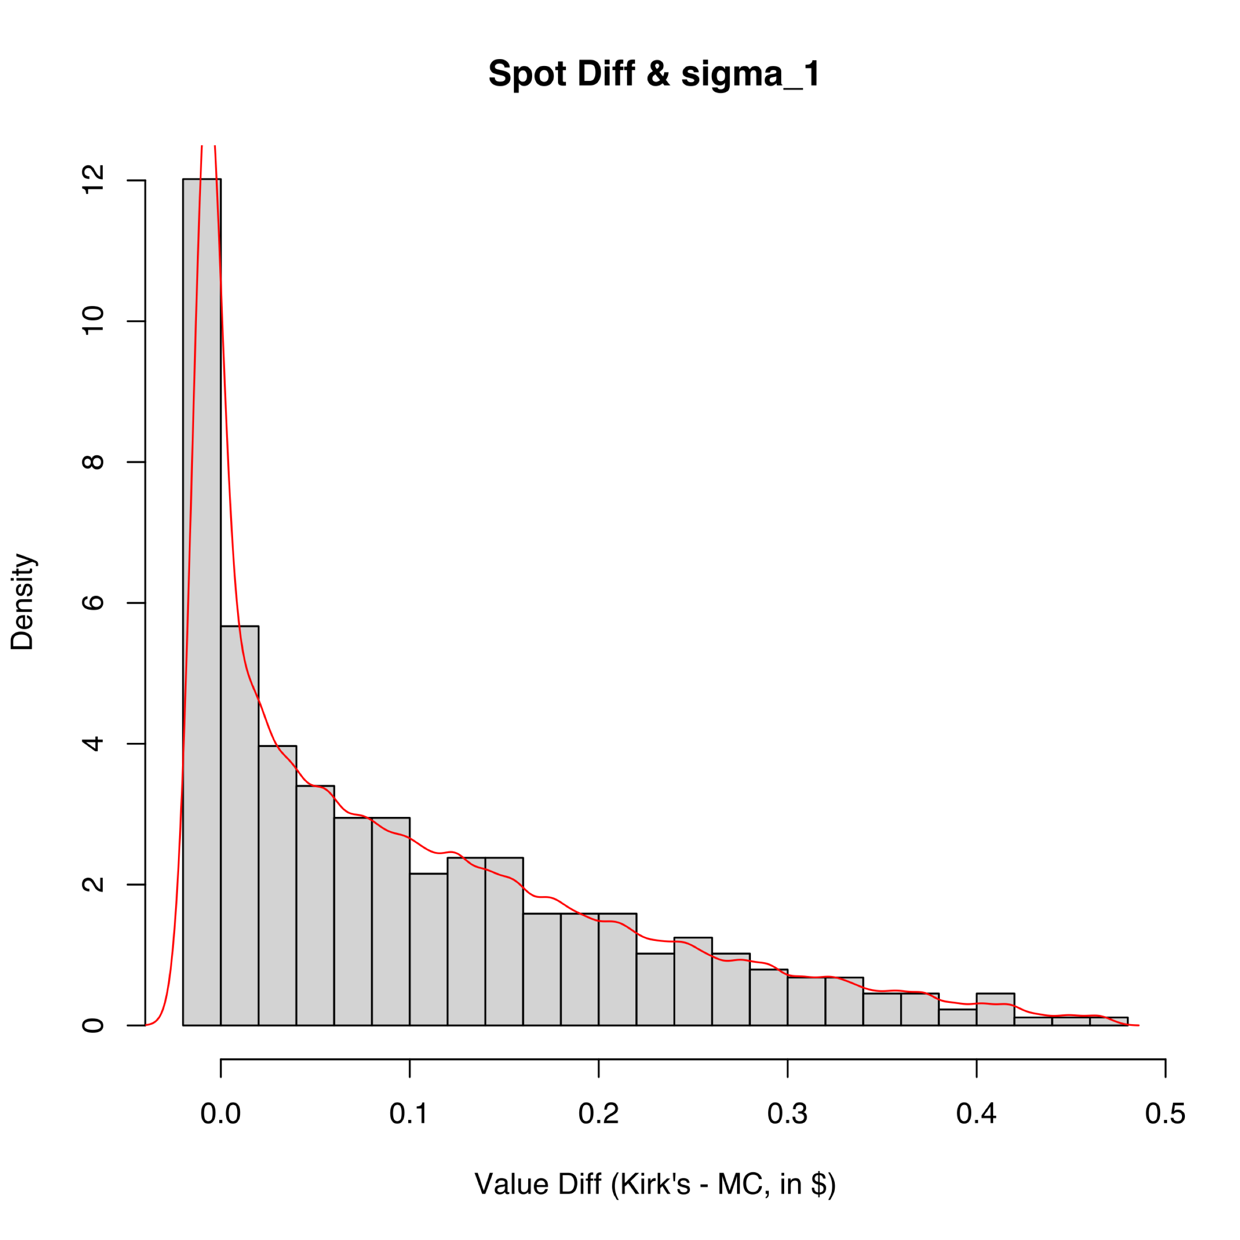

(a) (b)

Figure 2. The differences between Kirk’s and MC among various $SpotDiff$ 
 and $σ_{1}$, as in (a) grid plot, and in (b) histogram.

The value differences between Kirk’s and MC’s among the inspected $SpotDiff$– $σ_{1}$ pairs are plotted in Fig.2. The value difference ranging from $-0.02 to $0.46 has its mean at $0.10 and median at $0.06 with a positive skewness of 1.10 and a positive excess kurtosis of 0.46. Generally, larger spot differences or larger $σ_{1}$ would bring positive value differences.

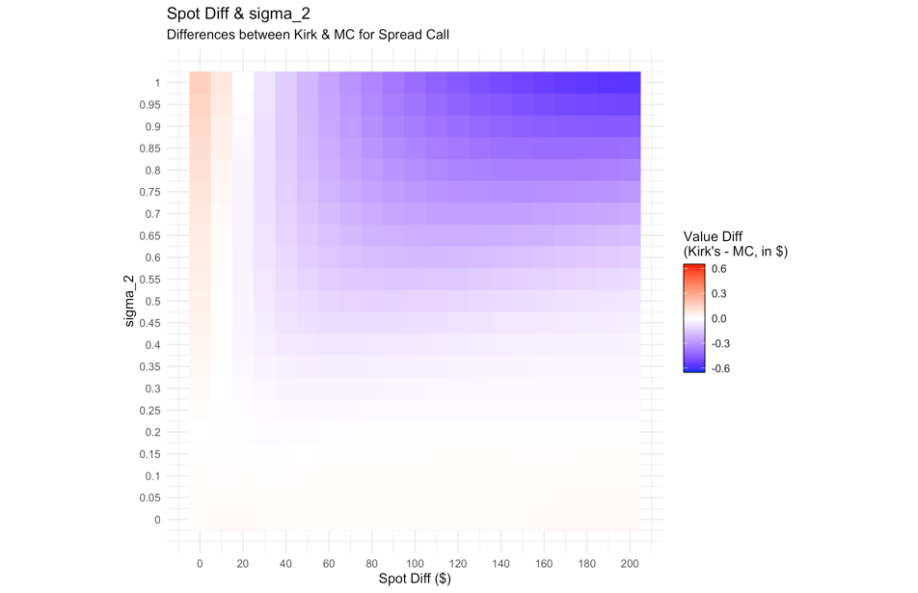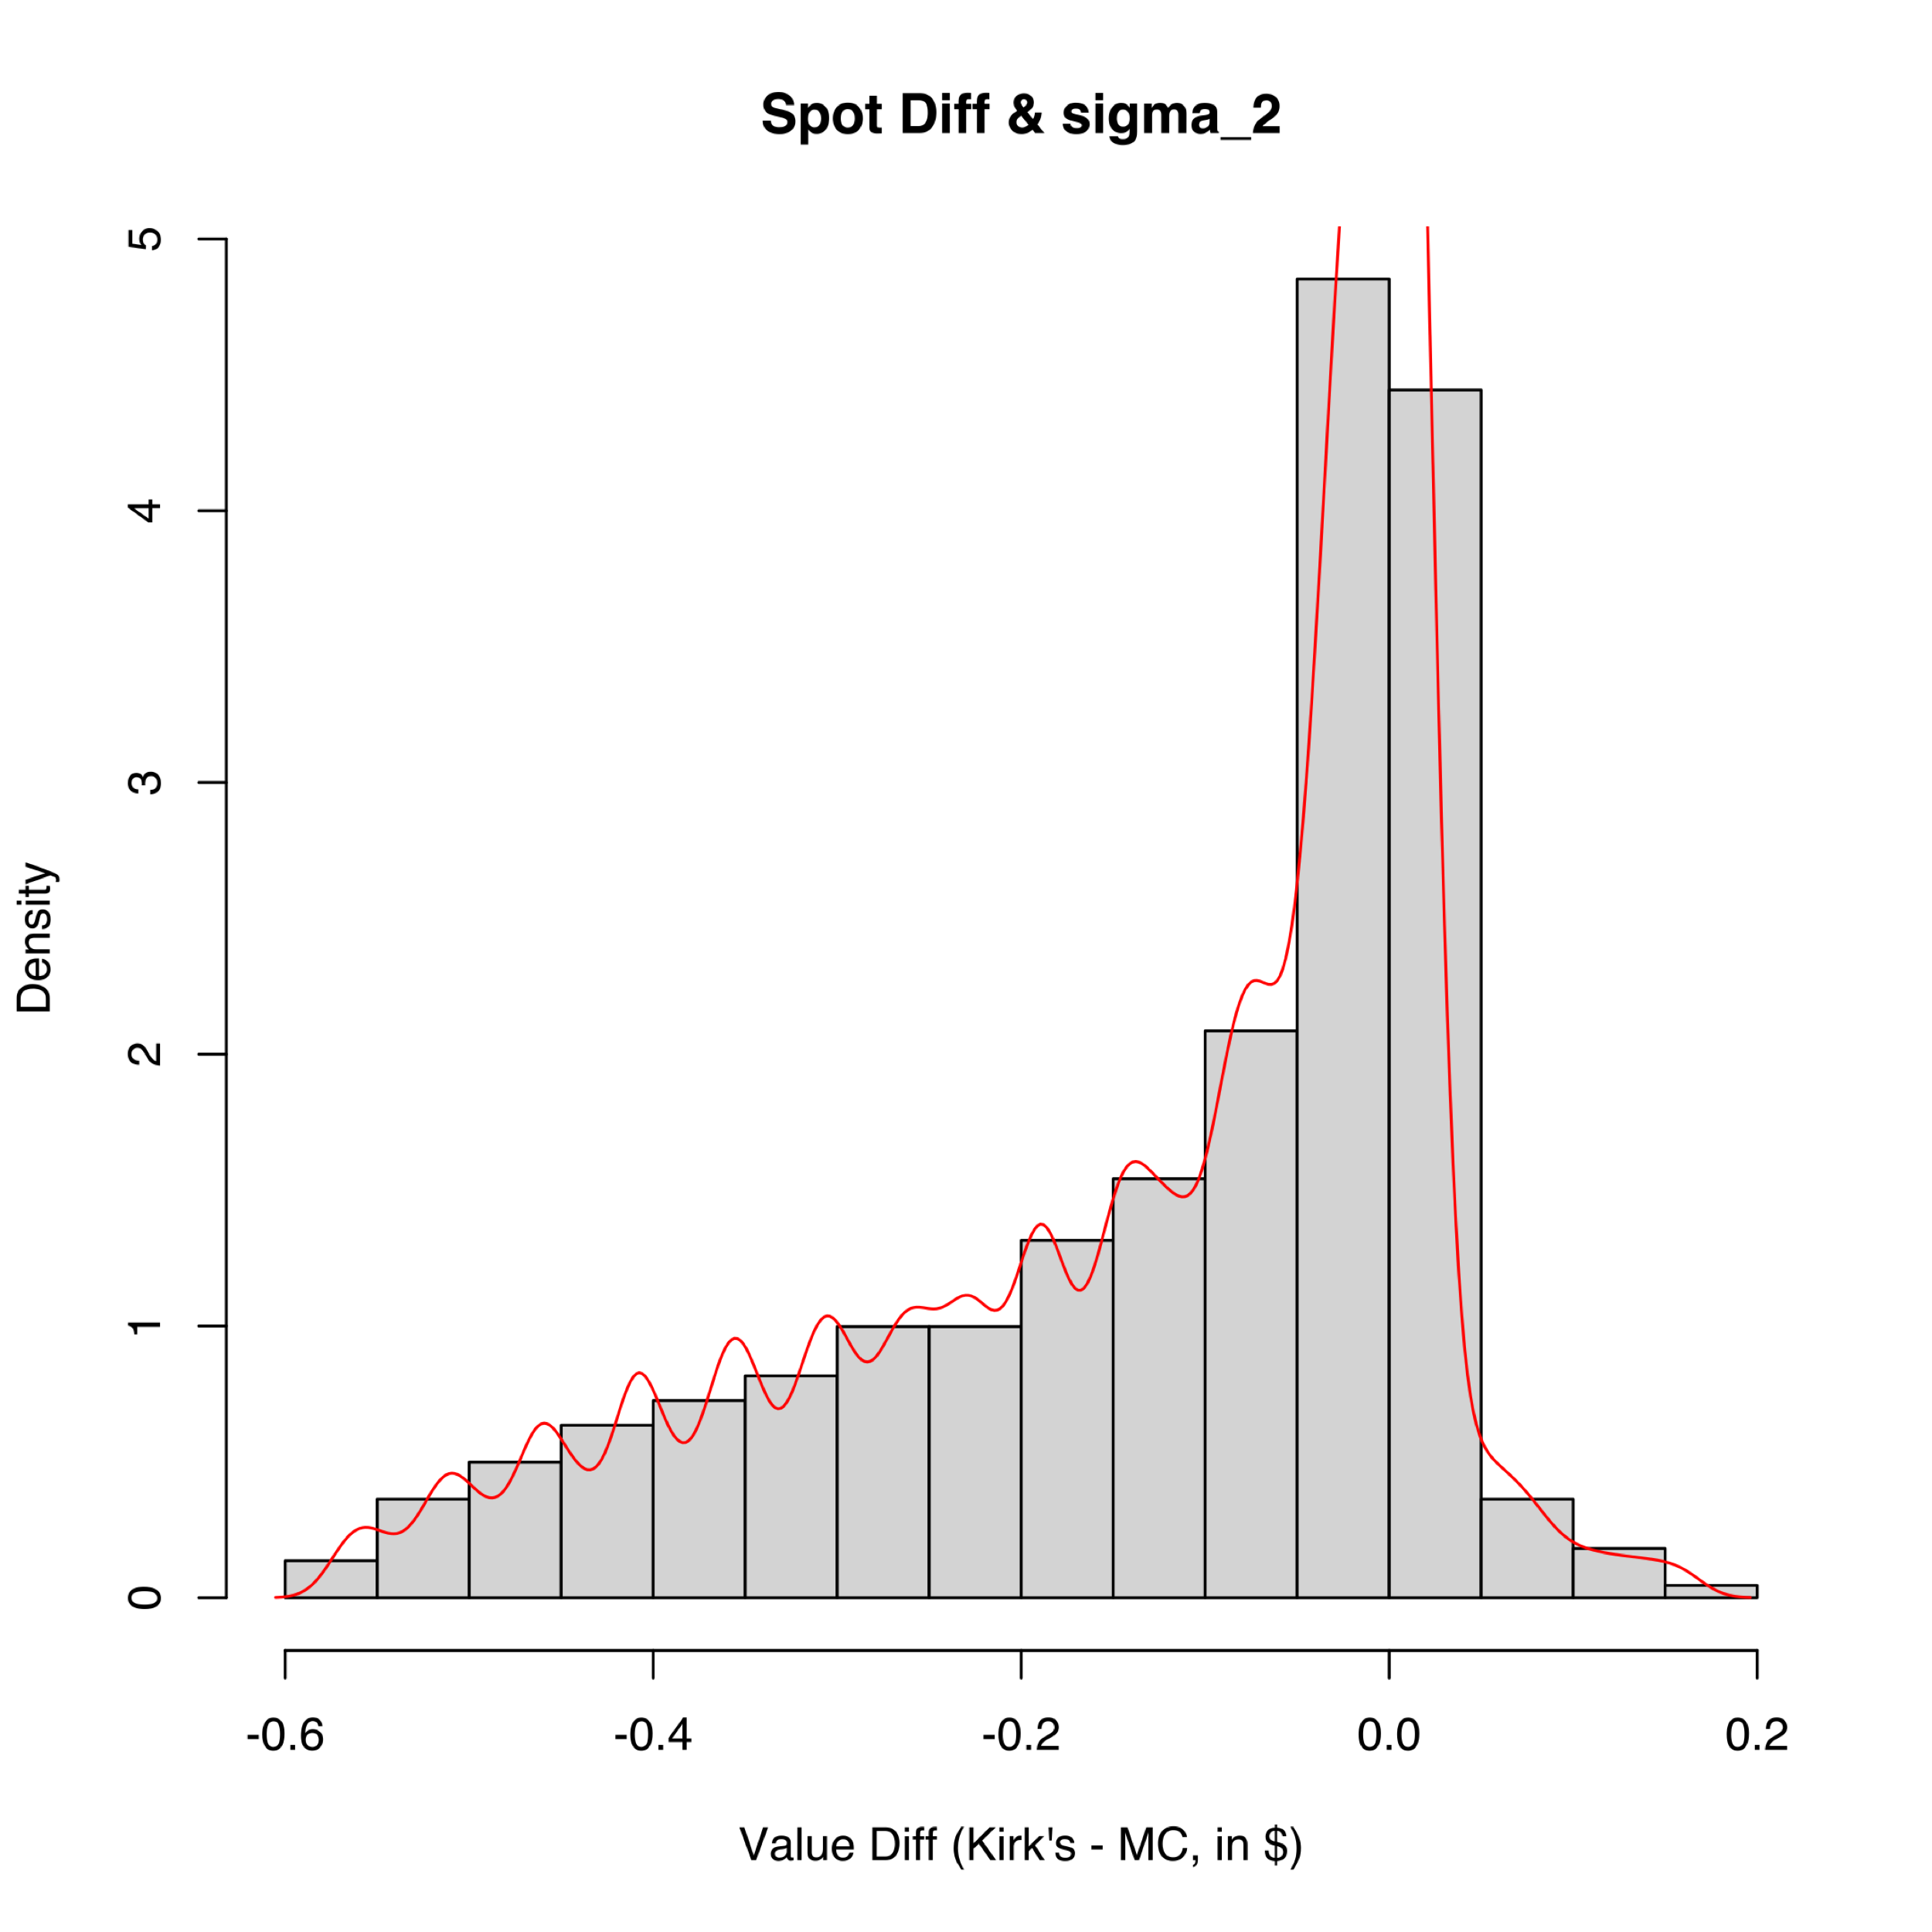

(a) (b)

Figure 3. The differences between Kirk’s and MC among various $SpotDiff$ 
 and $σ_{2}$, as in (a) grid plot, and in (b) histogram.

The value differences between Kirk’s and MC’s among the inspected $SpotDiff$– $σ_{2}$ pairs are plotted in Fig.3. The value difference ranging from $-0.57 to $0.16 has its mean at $-0.12 and median at $-0.05 with a negative skewness of -1.04 and a positive excess kurtosis of 0.10. At higher $σ_{2}$ level, larger spot differences would bring negative value differences.

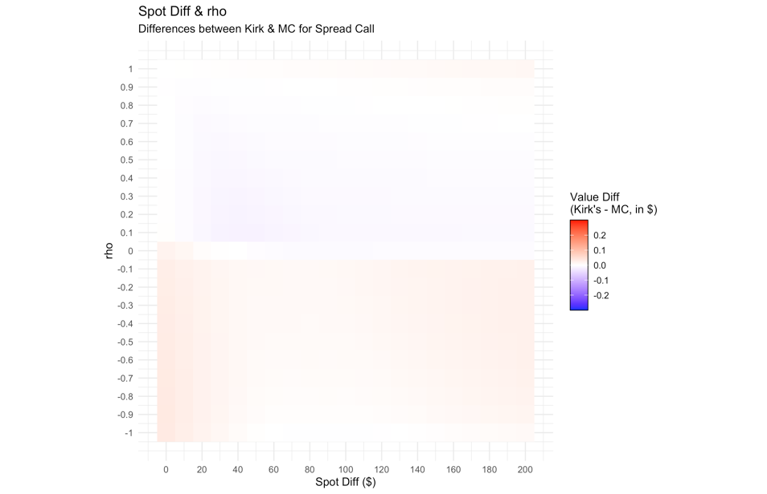 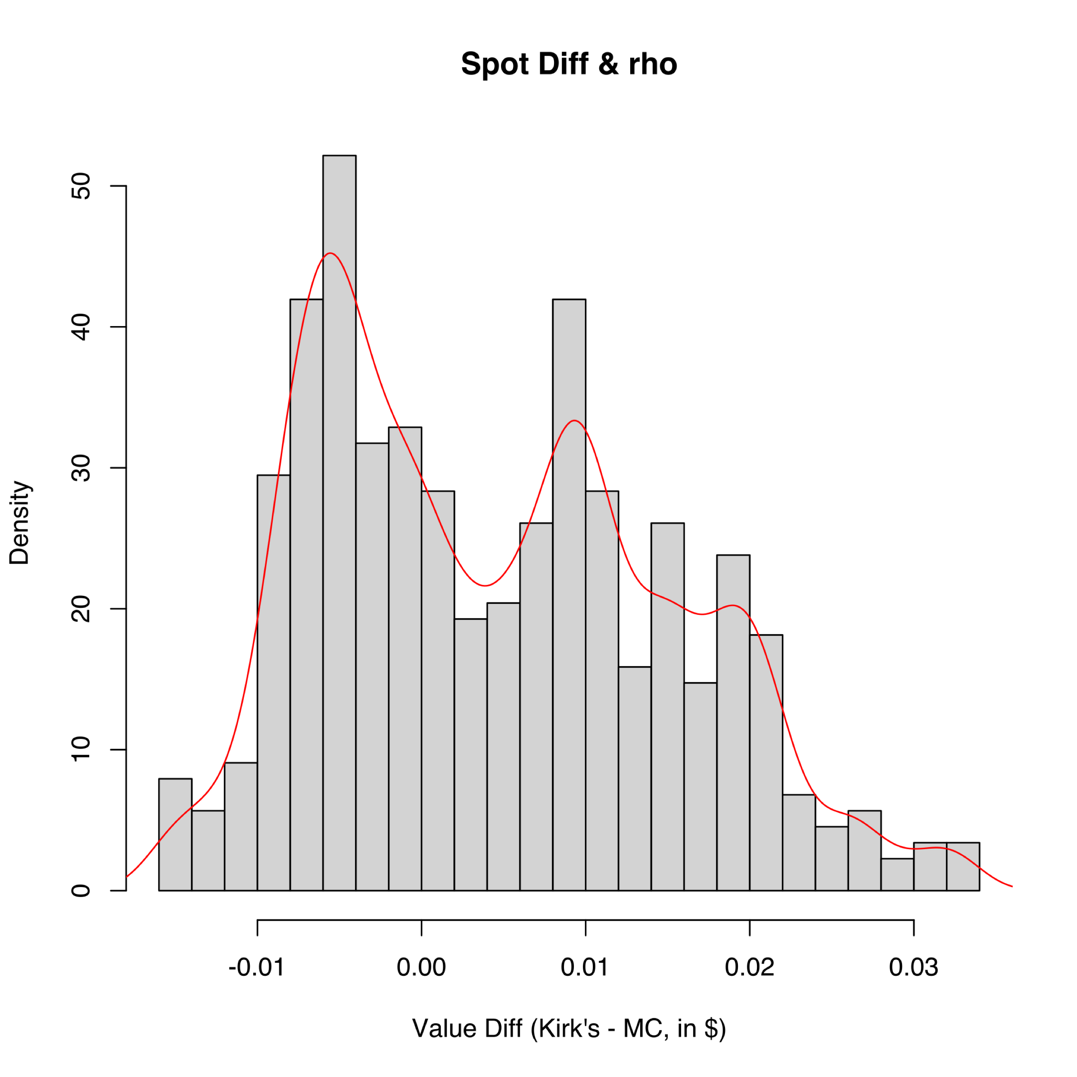

(a) (b)

Figure 4. The differences between Kirk’s and MC among various $SpotDiff$ 
 and $ρ$, as in (a) grid plot, and in (b) histogram.

The value differences between Kirk’s and MC’s among the inspected $SpotDiff$– $ρ$ pairs are plotted in Fig.4. The value difference ranging from $-0.02 to $0.03 has its mean at $0.00 and median at $0.00 with a positive skewness of 0.40 and a negative excess kurtosis of -0.70. Generally, positive correlation would bring negative value differences, and vice versa.

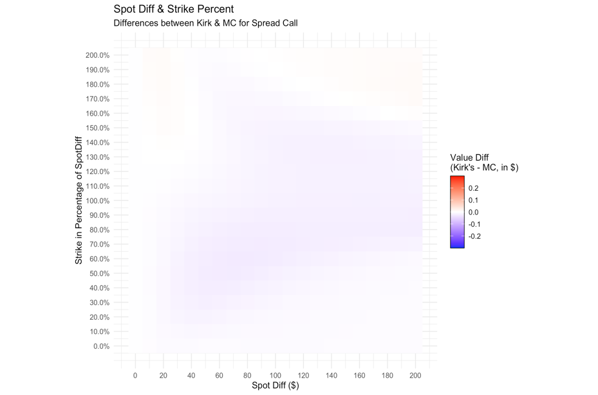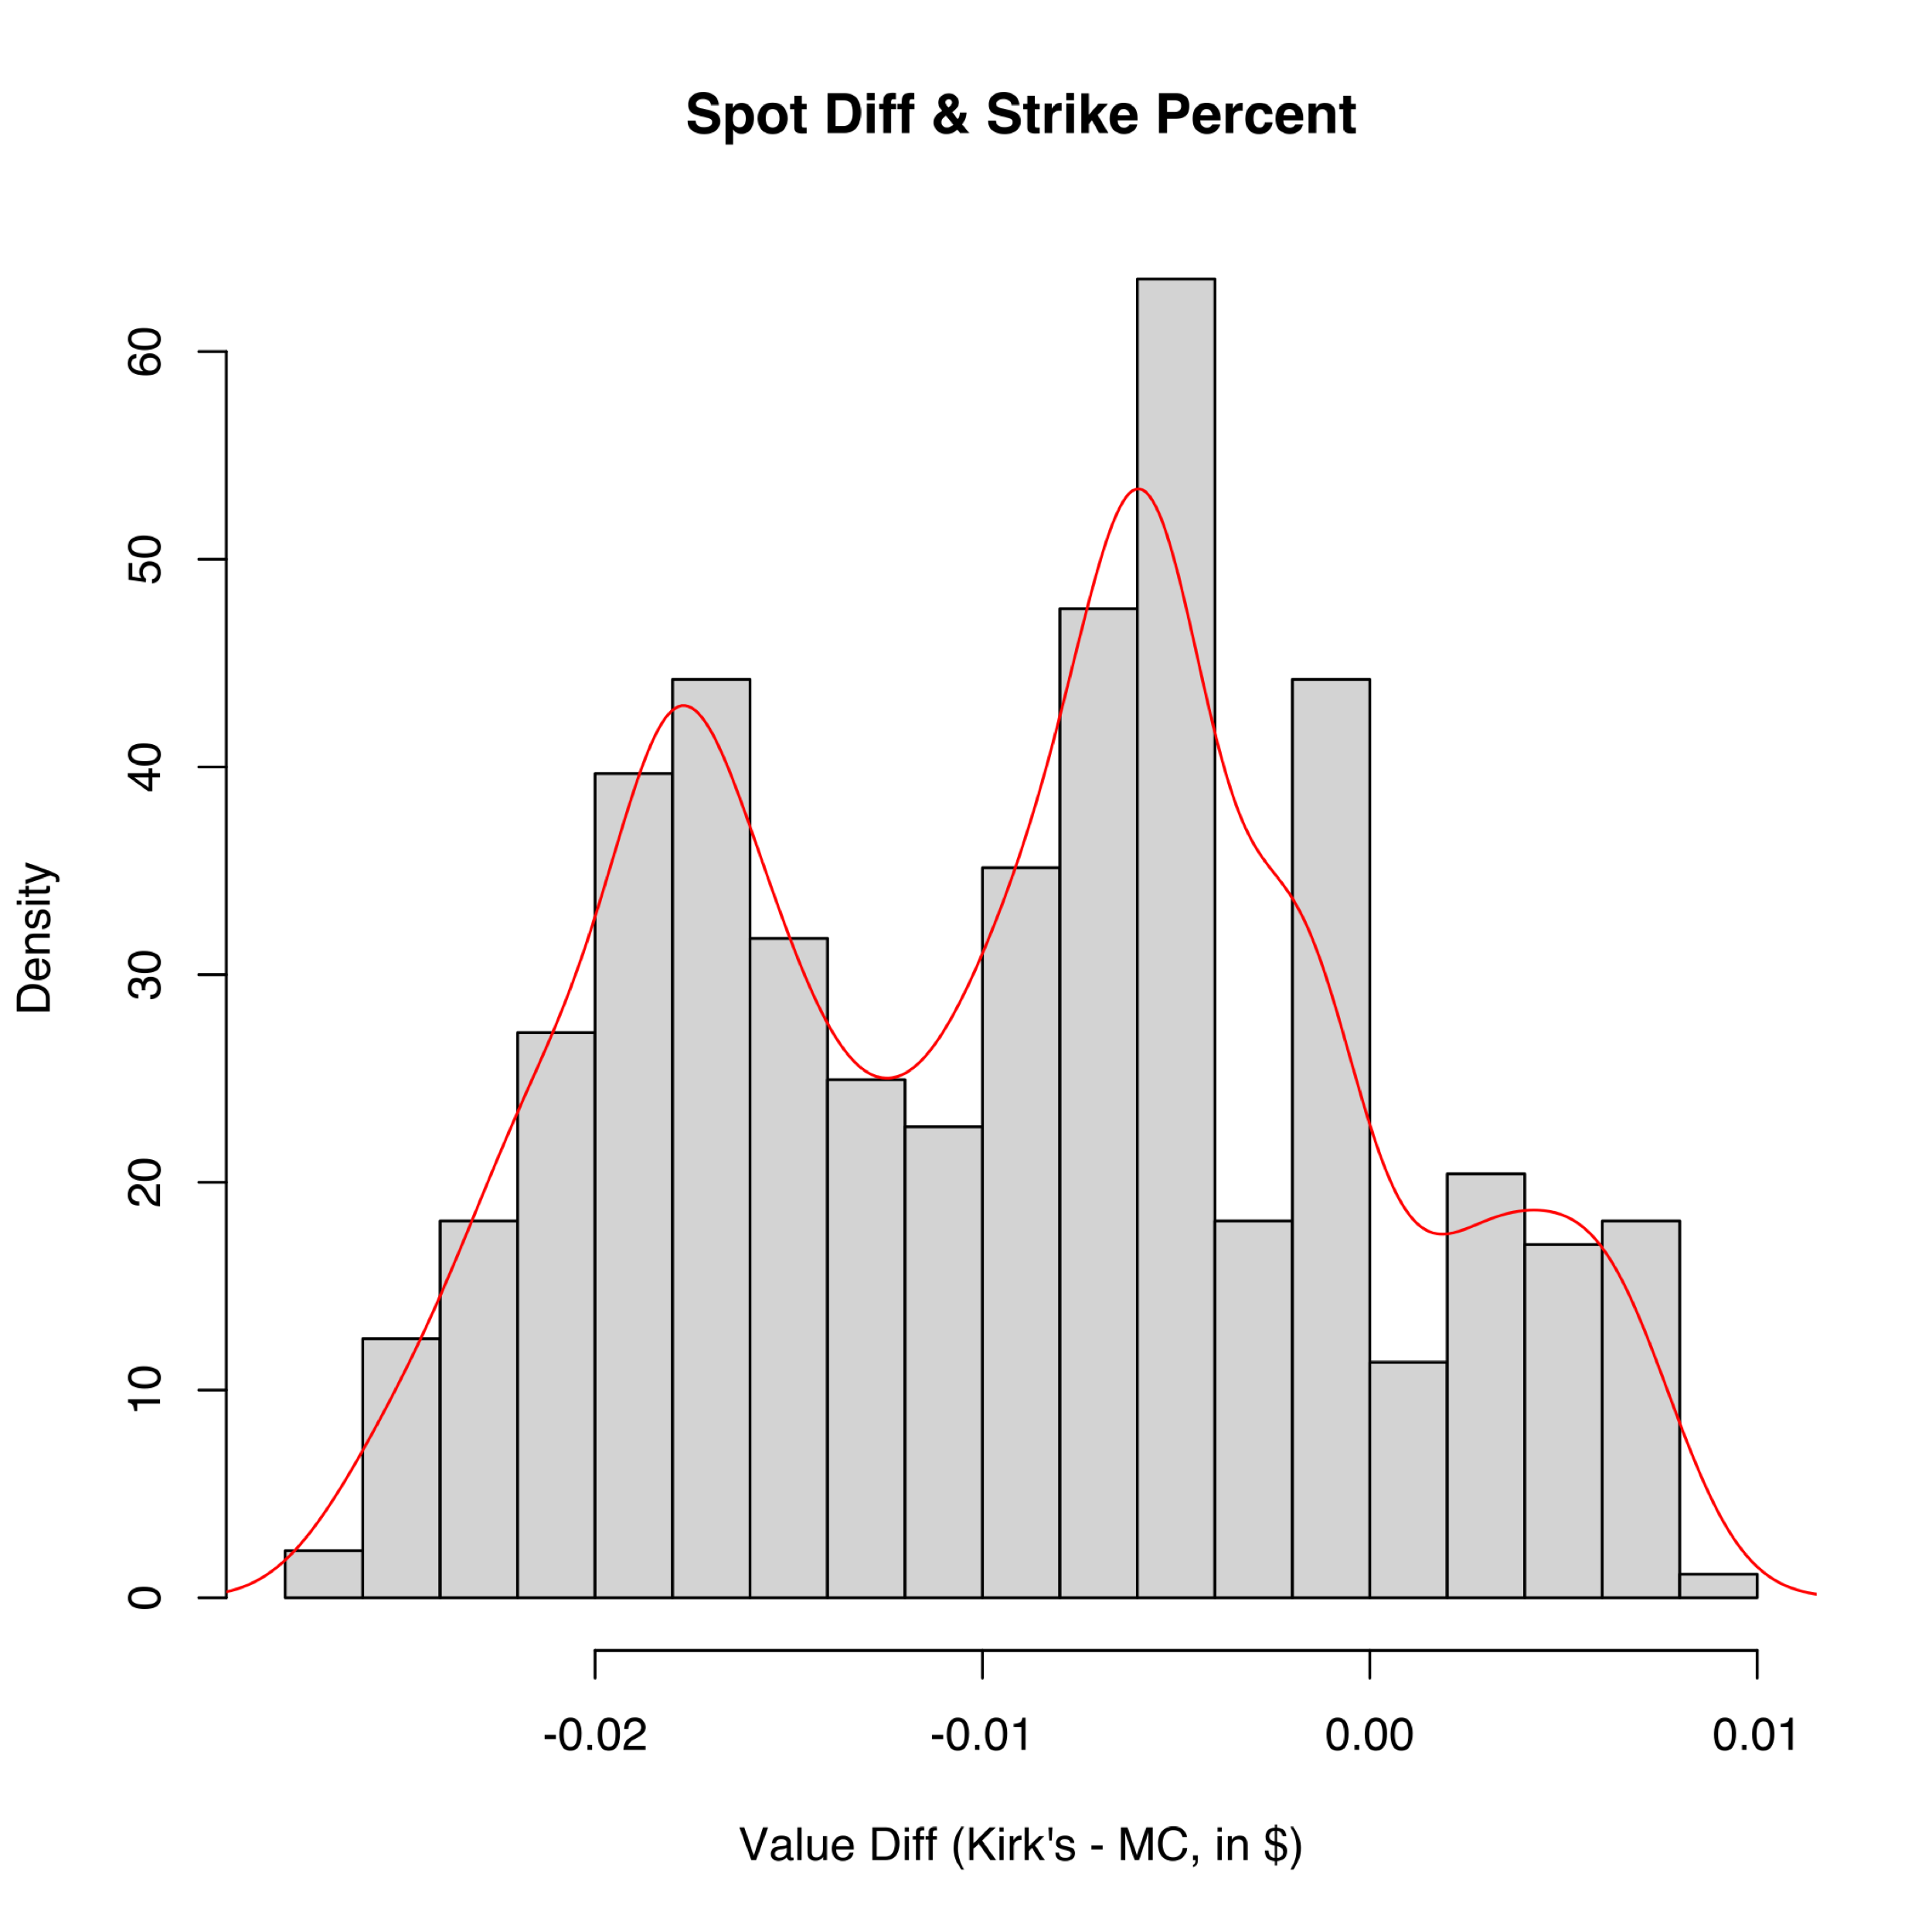

(a) (b)

Figure 5. The differences between Kirk’s and MC among various $SpotDiff$ 
 and Strike in percentage of $SpotDiff$, as in (a) grid plot, and in (b) histogram.

The value differences between Kirk’s and MC’s among the inspected $SpotDiff$– $\frac{K}{SpotDiff}$ pairs are plotted in Fig.5. The value difference ranging from $-0.03 to $0.01 has its mean at $-0.01 and median at $-0.01 with a positive skewness of 0.05 and a negative excess kurtosis of -0.92. The difference is more visible when the Strike is around the differences between two Spots.

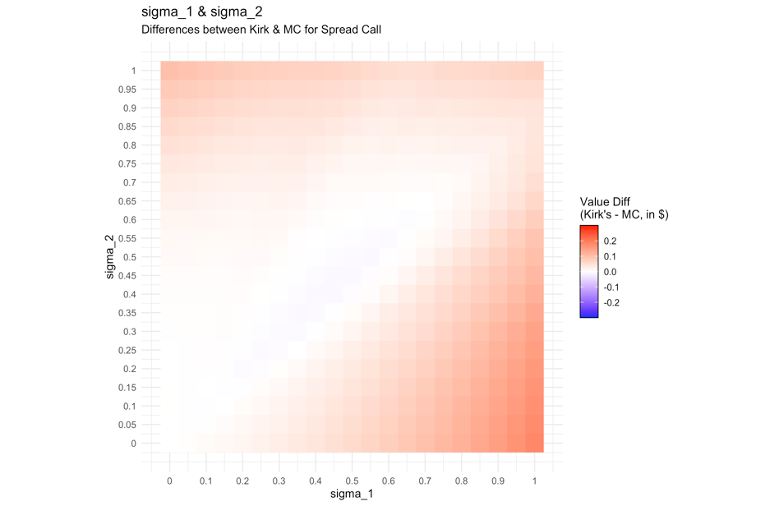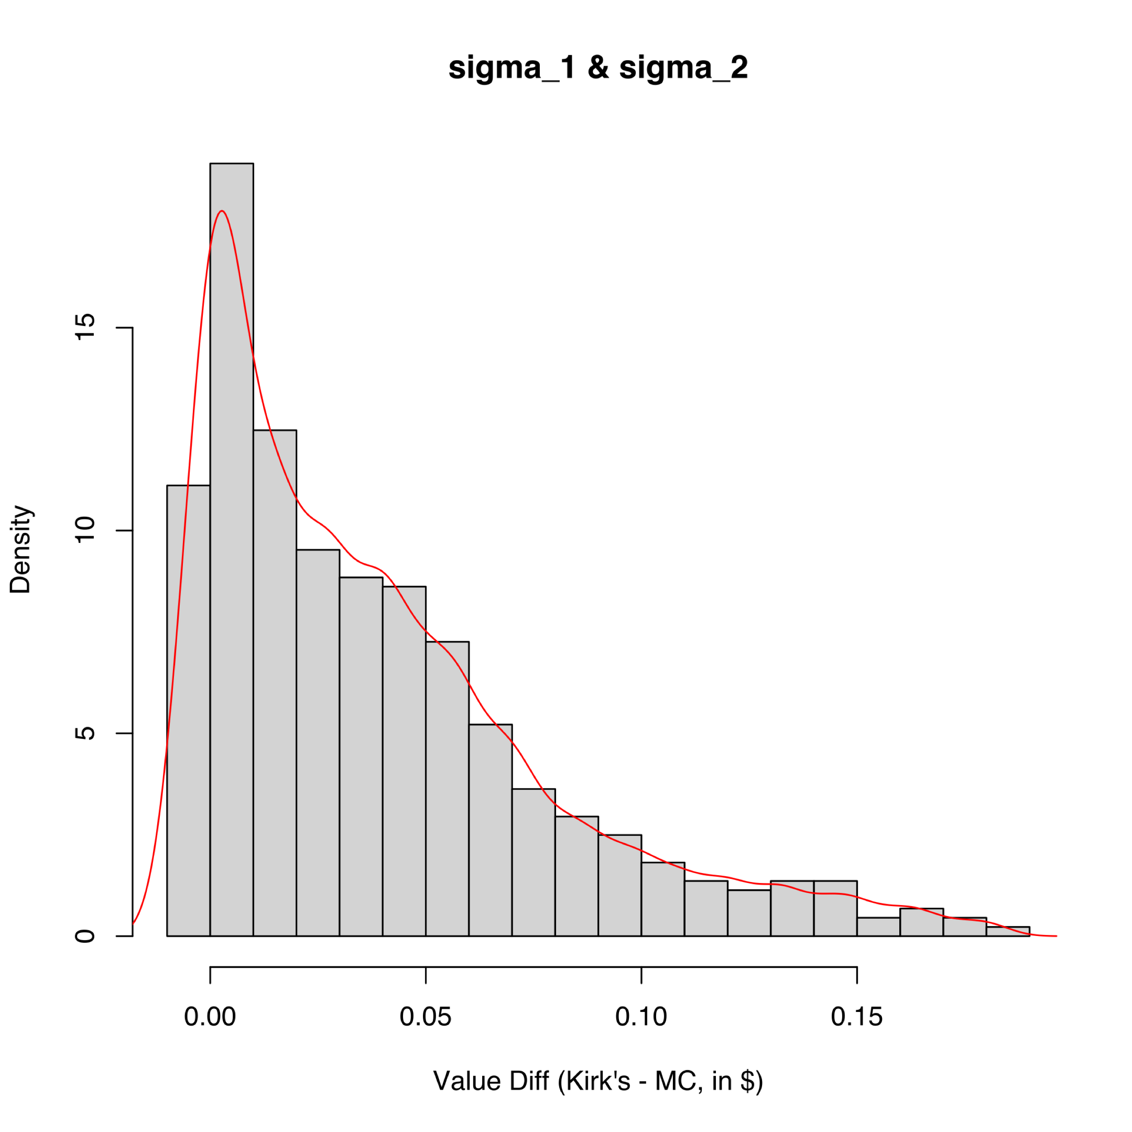

(a) (b)

Figure 6. The differences between Kirk’s and MC among various $σ_{1}$ 
 and $σ_{2}$, as in (a) grid plot, and in (b) histogram.

The value differences between Kirk’s and MC’s among the inspected $σ_{1}$– $σ_{2}$ pairs are plotted in Fig.6. The value difference ranging from $-0.01 to $0.18 has its mean at $0.04 and median at $0.03 with a positive skewness of 1.24 and a positive excess kurtosis of 1.19. Both larger $σ_{1}$ and larger $σ_{2}$ would bring positive value differences. The difference is minimized when $σ_{1}$ = $σ_{2}$.

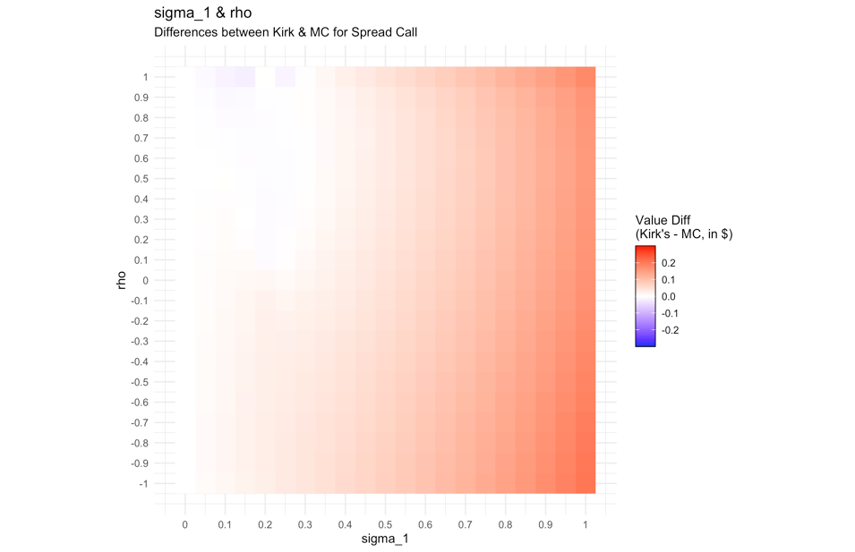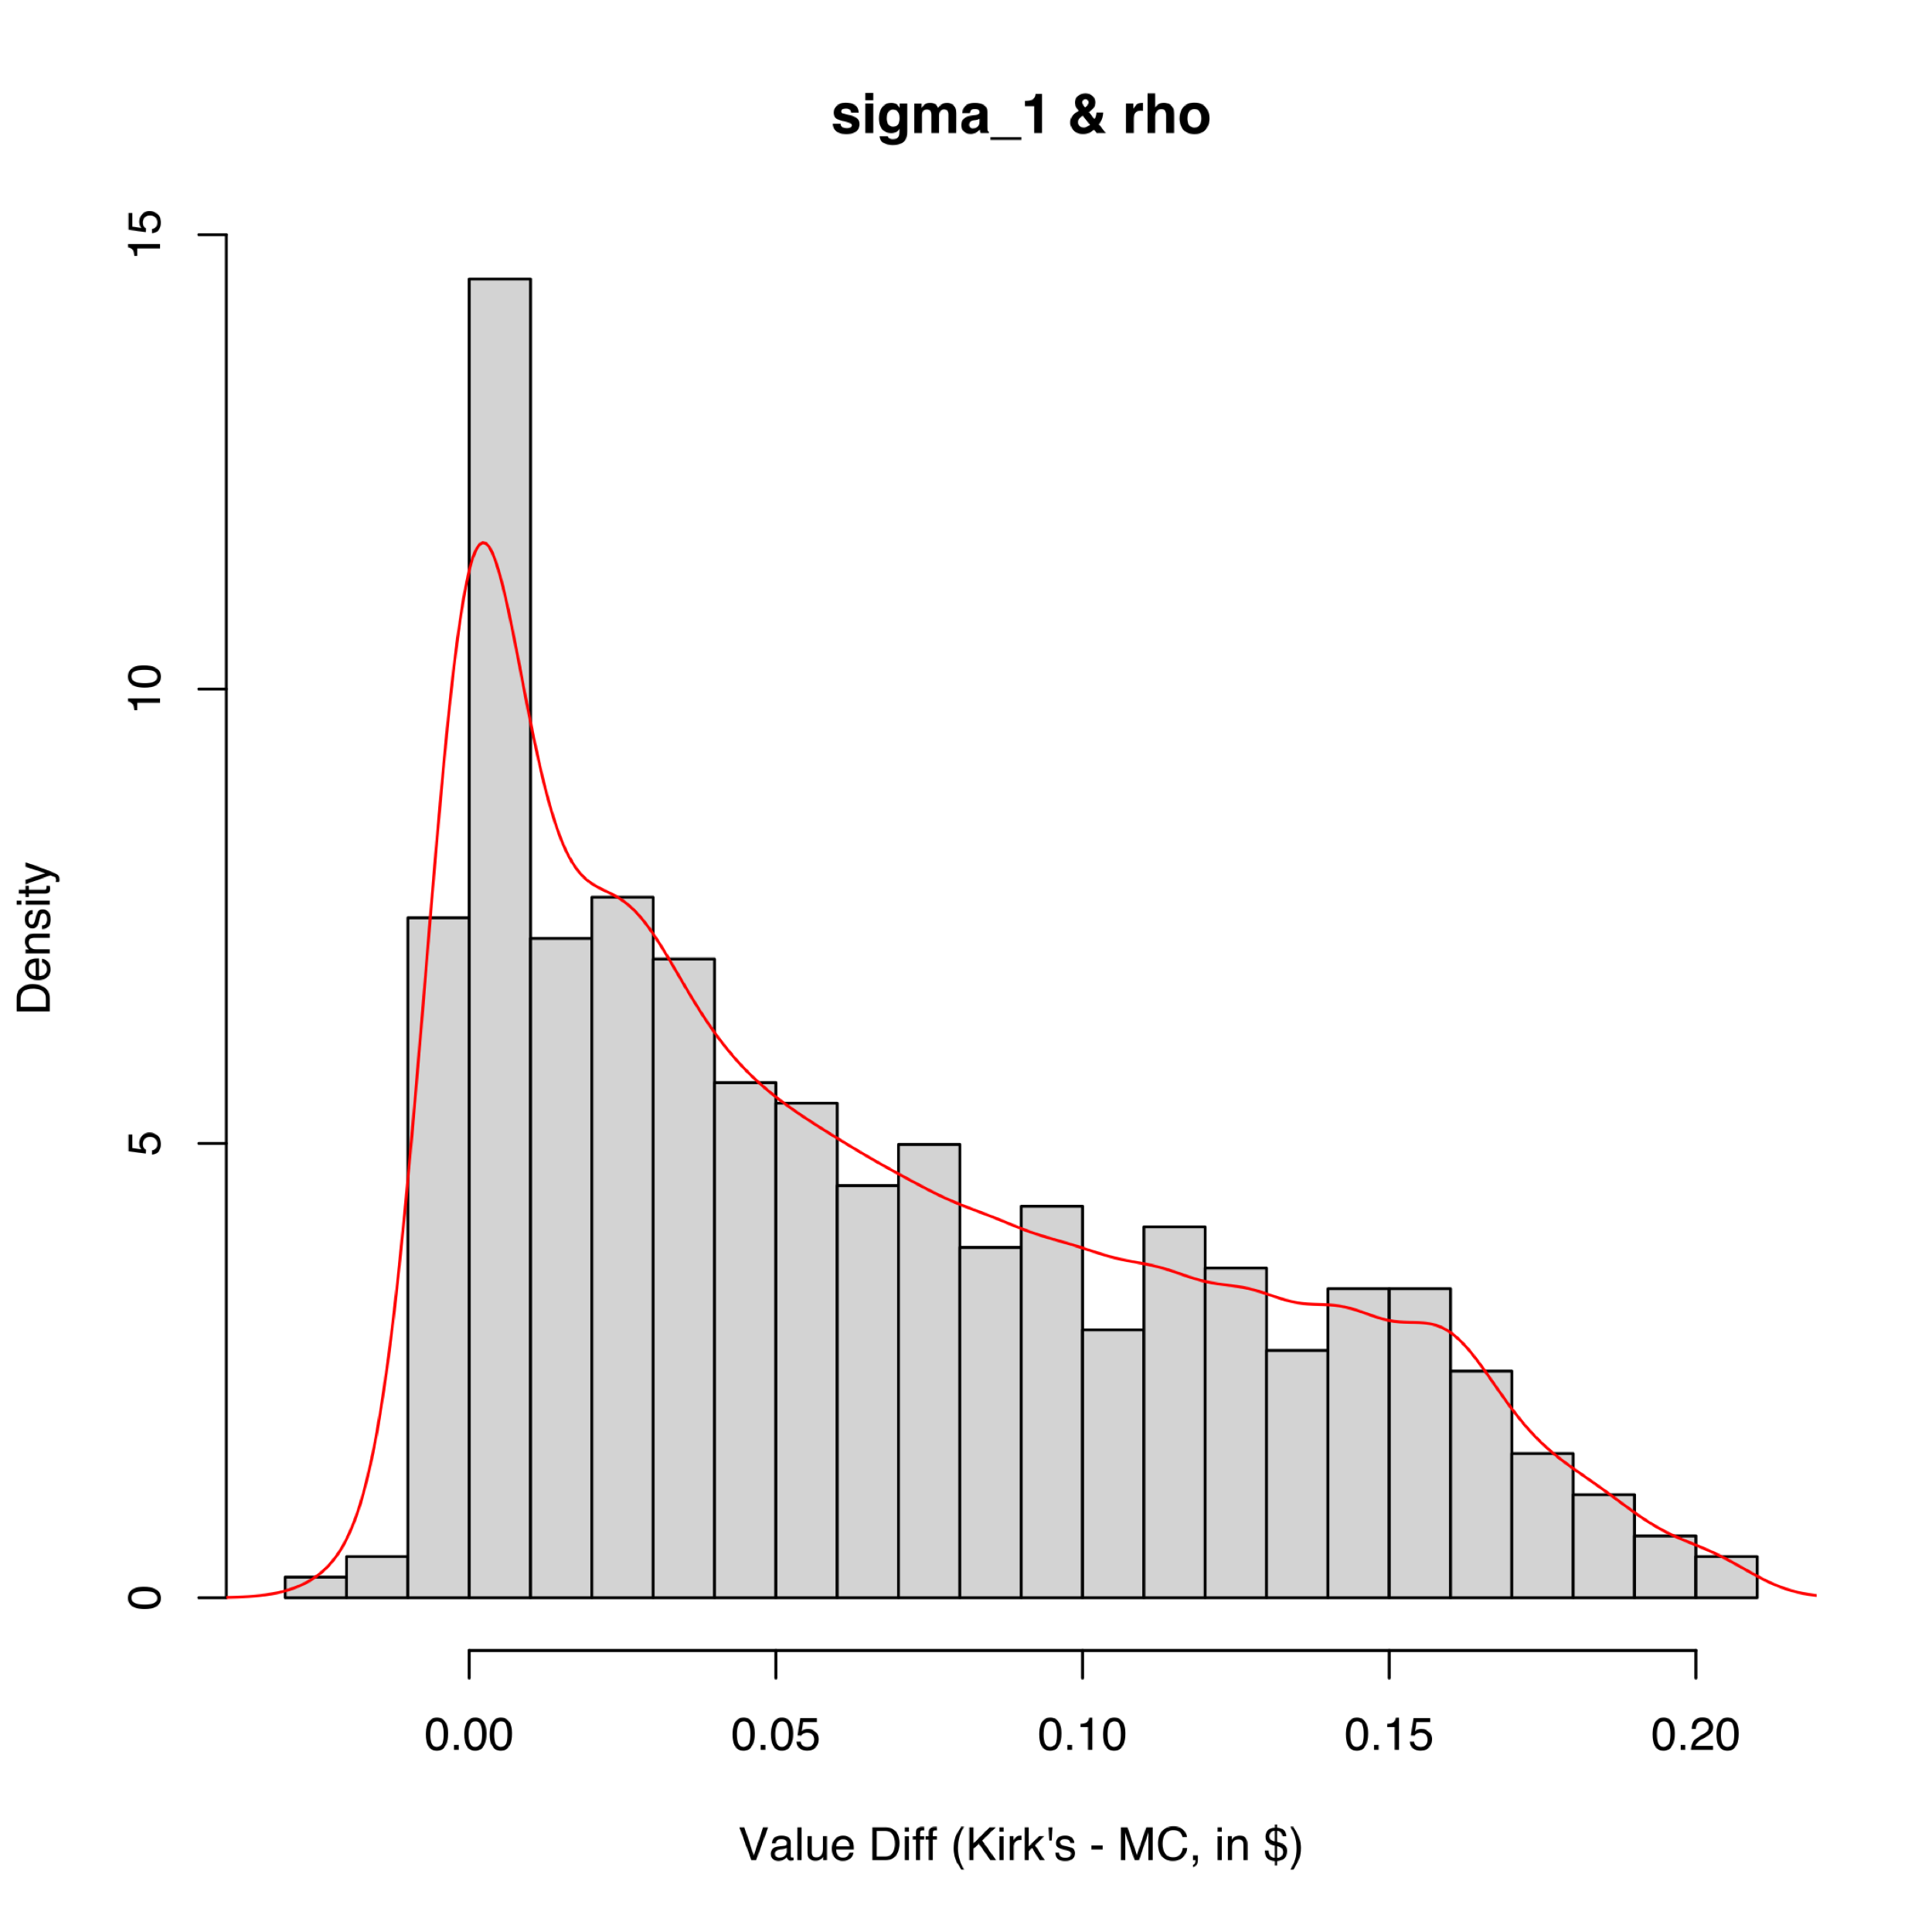 (a) (b)

Figure 7. The differences between Kirk’s and MC among various $σ_{1}$ 
 and $ρ$, as in (a) grid plot, and in (b) histogram.

The value differences between Kirk’s and MC’s among the inspected $σ_{1}$– $ρ$ pairs are plotted in Fig.7. The value difference ranging from $-0.02 to $0.21 has its mean at $0.06 and median at $0.05 with a positive skewness of 0.60 and a negative excess kurtosis of -0.77.

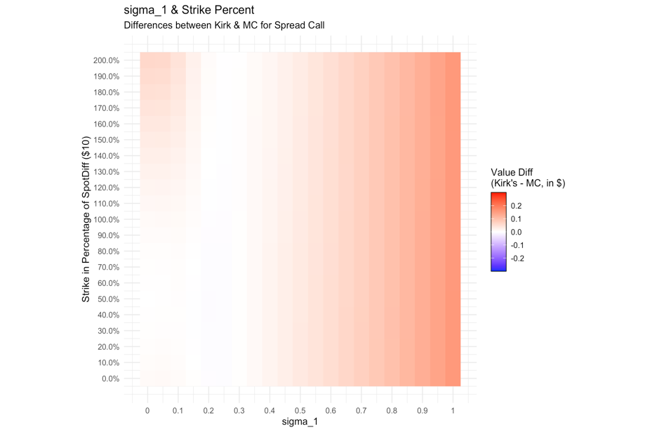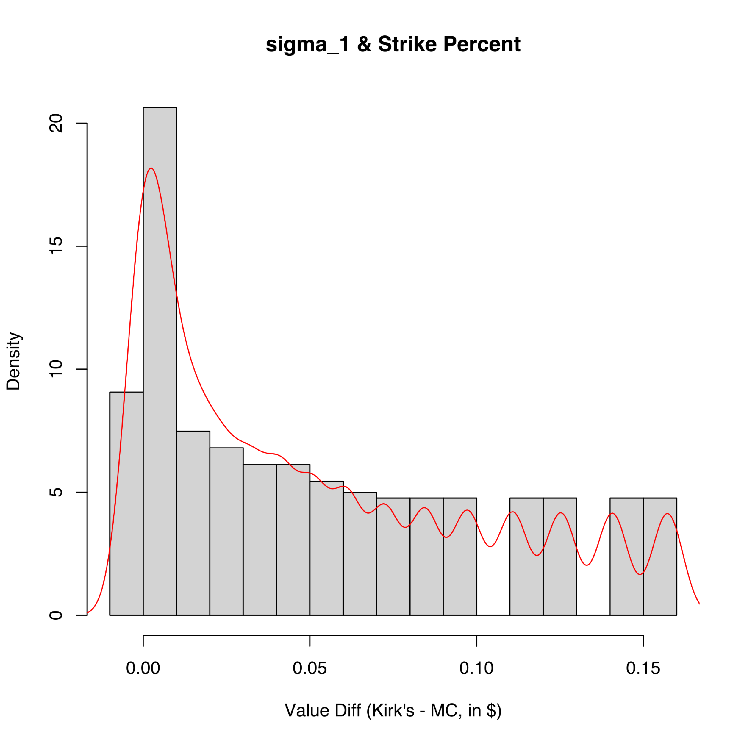

(a) (b)

Figure 8. The differences between Kirk’s and MC among various $σ_{1}$ 
 and Strike in percentage of $SpotDiff$, as in (a) grid plot, and in (b) histogram.

The value differences between Kirk’s and MC’s among the inspected $σ_{1}$– $\frac{K}{SpotDiff}$ pairs are plotted in Fig.8. The value difference ranging from $0.00 to $0.16 has its mean at $0.05 and median at $0.04 with a positive skewness of 0.71 and a negative excess kurtosis of -0.74.

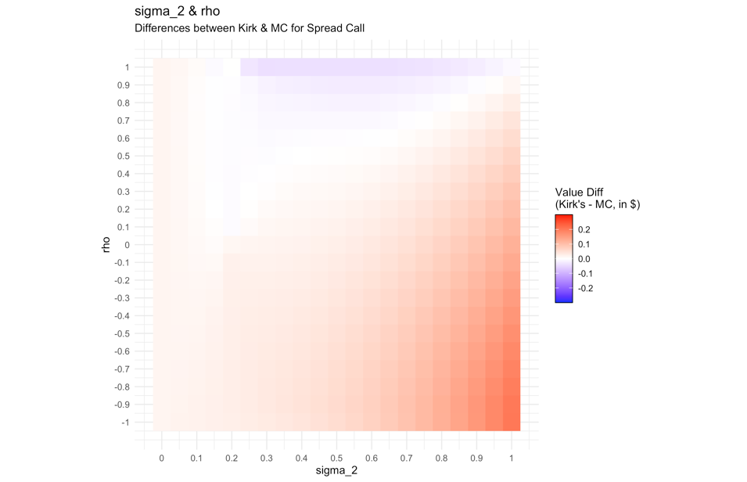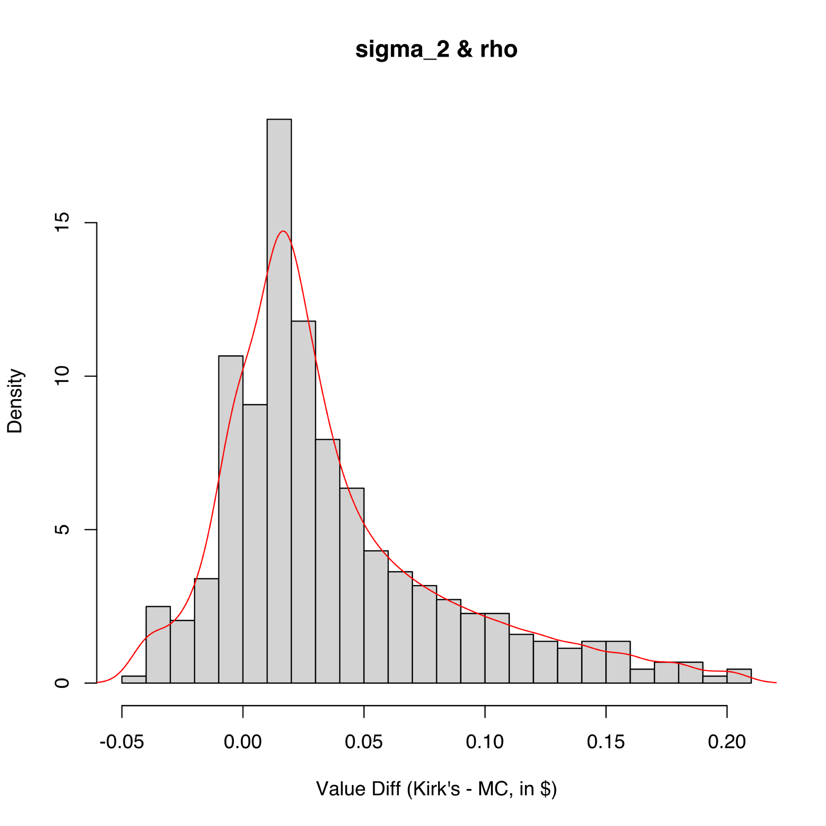

(a) (b)

Figure 9. The differences between Kirk’s and MC among various $σ_{2}$ 
 and $ρ$, as in (a) grid plot, and in (b) histogram.

The value differences between Kirk’s and MC’s among the inspected $σ_{2}$– $ρ$ pairs are plotted in Fig.9. The value difference ranging from $-0.04 to $0.20 has its mean at $0.04 and median at $0.02 with a positive skewness of 1.23 and a positive excess kurtosis of 1.34. Positive $ρ$ would bring negative differences that may offset the positive differences brought by larger $σ_{2}$.

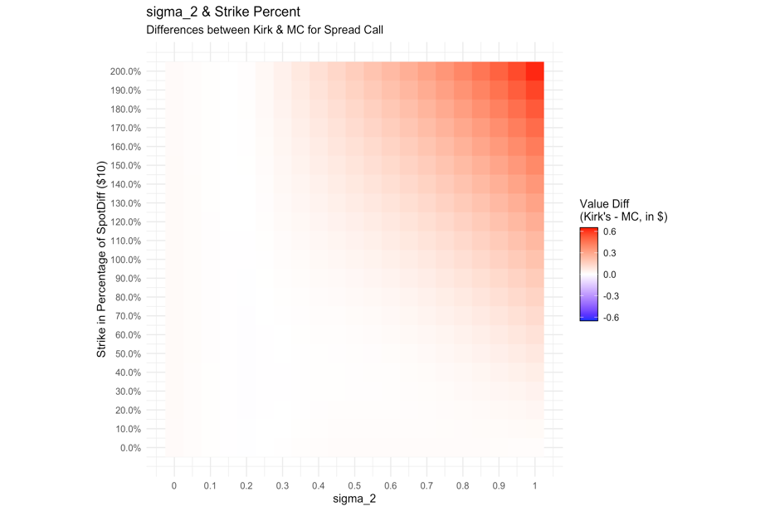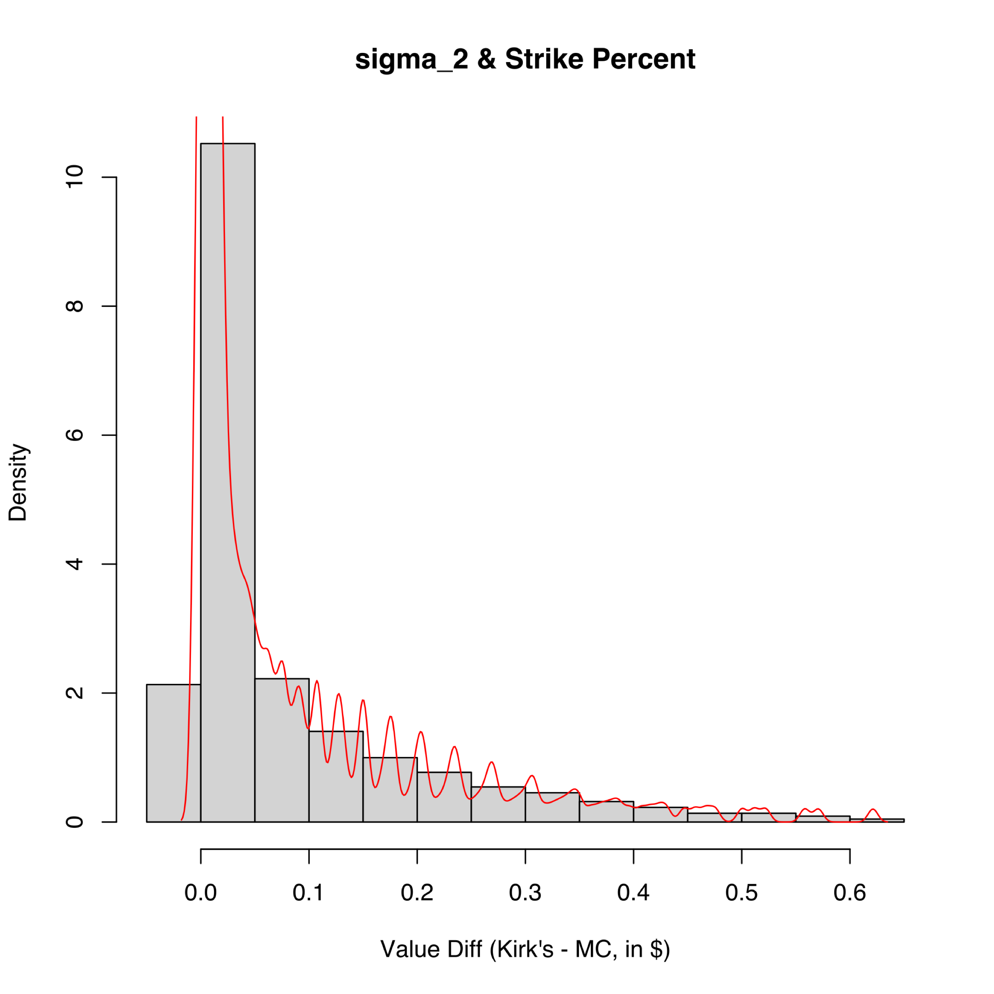

(a) (b)

Figure 10. The differences between Kirk’s and MC among various $σ_{2}$ 
 and Strike in percentage of $SpotDiff$, as in (a) grid plot, and in (b) histogram.

The value differences between Kirk’s and MC’s among the inspected $σ_{2}$– $\frac{K}{SpotDiff}$ pairs are plotted in Fig.10. The value difference ranging from $0.00 to $0.62 has its mean at $0.08 and median at $0.02 with a positive skewness of 2.08 and a positive excess kurtosis of 4.17. Both larger $σ_{2}$ and larger Strike would bring positive value differences.

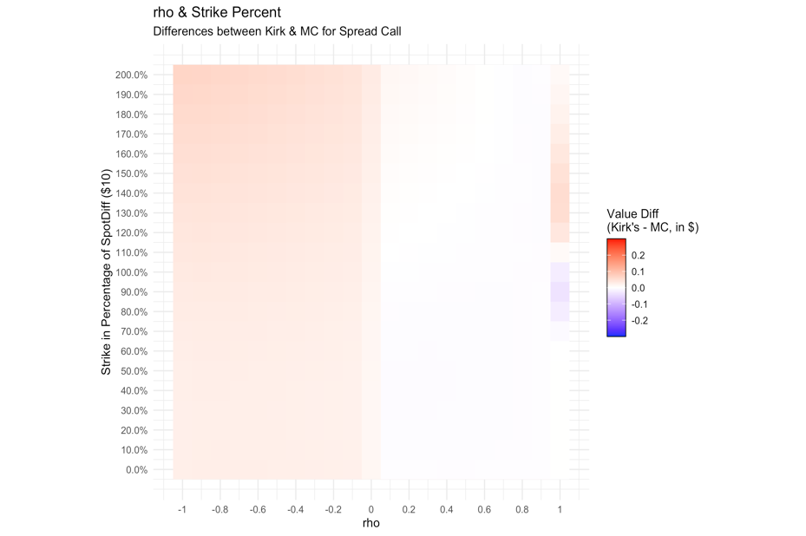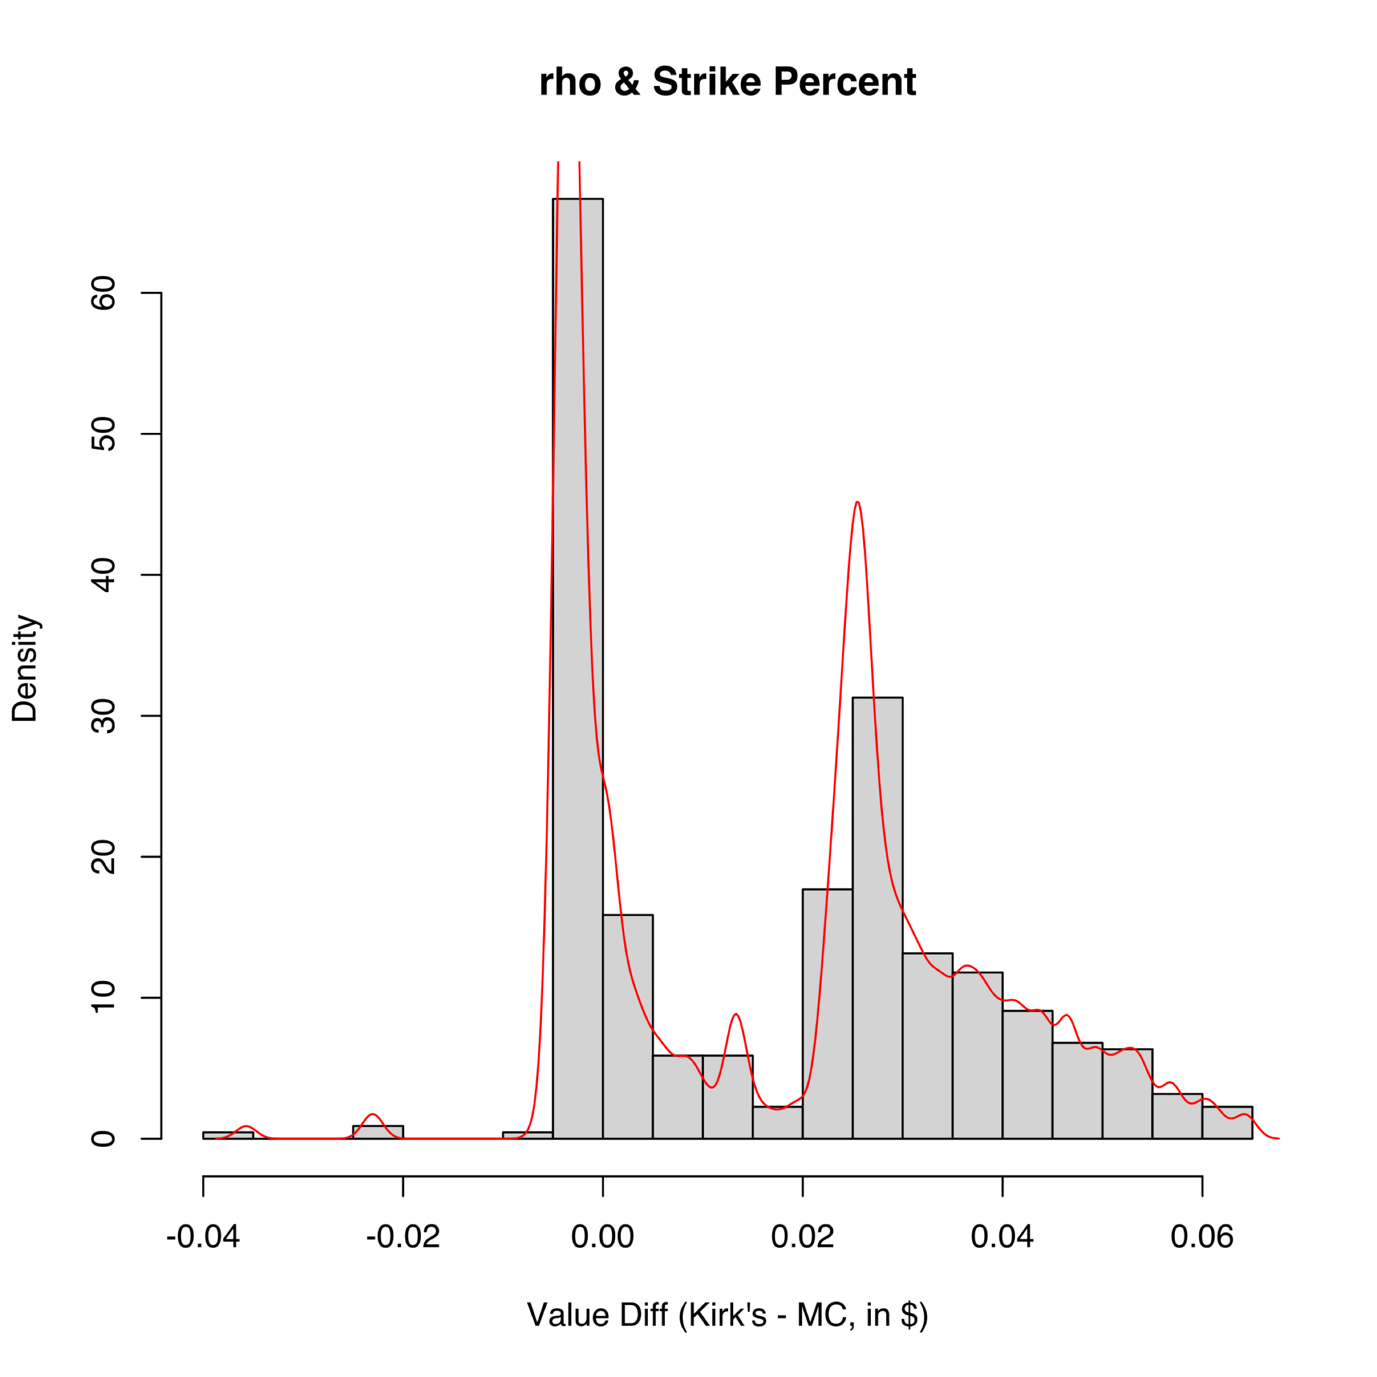  
(a) (b)

Figure 11. The differences between Kirk’s and MC among various $ρ$ 
 and Strike in percentage of $SpotDiff$, as in (a) grid plot, and in (b) histogram.

The value differences between Kirk’s and MC’s among the inspected $ρ$– $\frac{K}{SpotDiff}$ pairs are plotted in Fig.11. The value difference ranging from $-0.04 to $0.06 has its mean at $0.02 and median at $0.02 with a positive skewness of 0.31 and a negative excess kurtosis of -0.99.

# Conclusion

In this project we investigated and implemented Monte Carlo together with Kirk’s approximation on spread call options pricing, then further compared their performances in various scenarios. Generally, larger spot differences or larger $σ_{1}$ would bring positive value differences. At higher $σ_{2}$ level, larger spot differences would bring negative value differences. Generally, positive correlation would bring negative value differences, and vice versa. The difference is more visible when the Strike is around the differences between two Spots. Both larger $σ_{1}$ and larger $σ_{2}$ would bring positive value differences. The difference is minimized when $σ_{1}$ = $σ_{2}$. Positive $ρ$ would bring negative differences that may offset the positive differences brought by larger $σ_{2}$.

For future research, we would investigate the outcome of Kirk’s approximation in spread put option pricing, and compare its numerical performances with other approximation methods **[4], [8]**.

# References

[1] Paul Wilmott, *Paul Wilmott on Quantitative Finance*. 2006.

[2] W. Margrabe, “The Value of an Option to Exchange One Asset for Another,” *J. Finance*, vol. 33, no. 1, p. 177, 1978.

[3] J. Choi, “Sum of all Black–Scholes–Merton models: An efficient pricing method for spread, basket, and Asian options,” *J. Futur. Mark.*, vol. 38, no. 6, pp. 627–644, 2018.

[4] M. Li, S. J. Deng, and J. Zhou, “Closed-form approximations for spread option prices and Greeks,” *J. Deriv.*, 2008.

[5] E. Kirk and J. Aron, “Correlation in the energy markets,” *Manag. energy price risk*, vol. 1, pp. 71--78, 1995.

[6] H. Wickham *et al.*, “Welcome to the Tidyverse,” *J. Open Source Softw.*, vol. 4, no. 43, p. 1686, 2019.

[7] H. Wickham, *ggplot2: Elegant Graphics for Data Analysis*. 2016.

[8] N. D. Pearson, “An Efficient Approach for Pricing Spread Options,” *J. Deriv.*, vol. 3, no. 1, pp. 76–91, 1995.

# Appendix

1. Spread Call Monte Carlo Pricing and Kirk’s Approximation in Python Codes, by Gao Jichen
2. Comparison & Visualization in R Codes, by Cheng Tuoyuan